Task 1
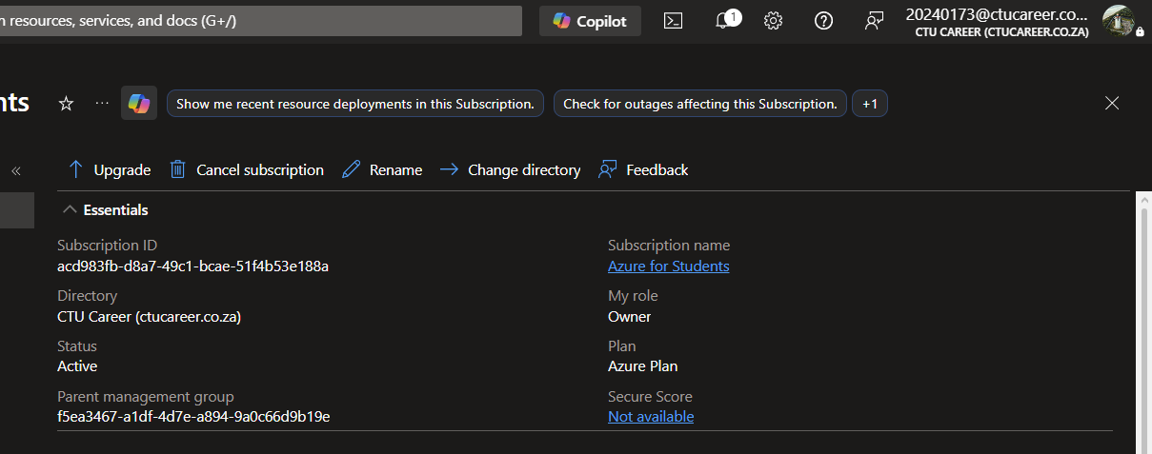
Task 2
CTU Training Solutions is a tertiary education institution with multiple campuses across South Africa. The organization places a strong emphasis on IT, Engineering, and Business-related programs. Its IT requirements are quite extensive, as each campus serves hundreds of students and approximately a dozen teachers.
CTU follows a Bring Your Own Device (BYOD) policy for its learners. To reduce operational overhead, students will not be granted direct access to the Azure portal. Additionally, CTU does not provide software applications directly to students; instead, they subscribe to third-party applications.
A cloud solution would greatly benefit CTU by offering centralized storage that enables all campuses to submit and access data efficiently. Azure’s robust backup capabilities would also support auditing processes. When combined with Azure’s strong security features, this would ensure that all institutional data is securely stored and properly managed.
Security is particularly critical because CTU handles sensitive information such as students’ ID numbers and their sponsors’ details. Implementing a high-end security solution is essential to protect this data. A breach of such sensitive information could result in severe reputational damage, as demonstrated by the Campus Online hack on 16 April 2025, which significantly eroded student trust in CTU.
The scale of the proposed solution should be appropriate for a medium-sized organization, as CTU employs around 100 teachers and essential staff members across the country.
Task 3
Azure Service | Purpose / Why you need it | Week it is used
Resource Group | A logical container used to manage azure resources | 1
Virtual Network (VNet) | A virtual network in Azure | 2
Virtual Machine (VM – B1s) | IaaS that allows to create a digital instance of a computer | 3
Microsoft Entra ID | Azure’s Identity Solution | 4
Network Security Group (NSG) | Controls in-outbound traffic in Azure resources | 5
Azure Storage Account | Azure’s storage location | 5
Microsoft Defender for Cloud | Provides a robust and effective security solution for azure | 6
Azure Monitor | Tracks as well as logs health and performance of azure services | 7
Azure Cost Management | Allows for the creation of bills and spending limits | 8

Task 4
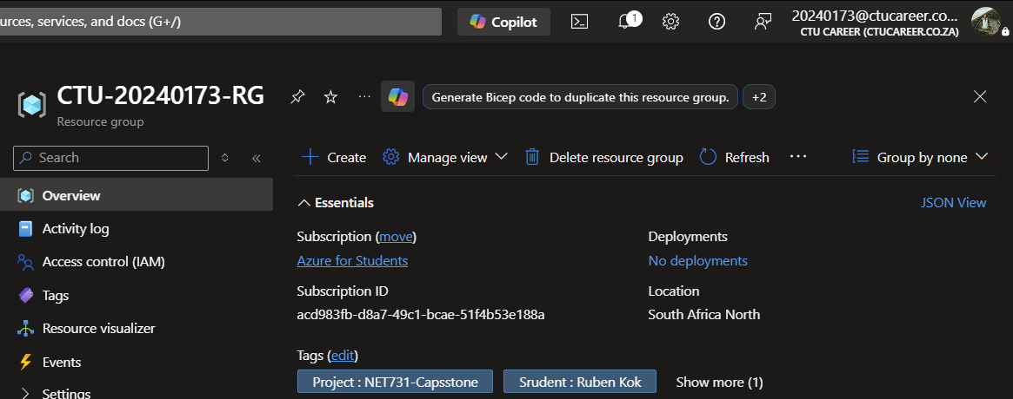

Bibliography
learn.microsoft.com. (n.d.). Azure Monitor overview. Retrieved from learn.microsoft.com: https://learn.microsoft.com/en-us/azure/azure-monitor/fundamentals/overview
learn.microsoft.com. (n.d.). Azure network security groups overview. Retrieved from learn.microsoft.com: https://learn.microsoft.com/en-us/azure/virtual-network/network- security-groups-overview
learn.microsoft.com. (n.d.). Overview of storage accounts. Retrieved from learn.microsoft.com: https://learn.microsoft.com/en-us/azure/storage/common/storage-account-overview
learn.microsoft.com. (n.d.). What is Azure Virtual Network? Retrieved from learn.microsoft.com: https://learn.microsoft.com/en-us/azure/virtual-network/virtual-networks-overview
learn.microsoft.com. (n.d.). What is Microsoft Defender for Cloud? Retrieved from learn.microsoft.com: https://learn.microsoft.com/en-us/azure/defender-for-cloud/defender- for-cloud-introduction
Rico, N. (n.d.). Understanding Resource Groups in Azure. Retrieved from tutorialsdojo.com: https://tutorialsdojo.com/understanding-resource-groups-in-azure/

